Part 1:

Function Code:

module freqDivider1(clk, reset, out);

input wire clk, reset;

output wire out;

reg [31:0] count_r; // current value

wire [31:0] count_n; // next value

always@(posedge clk)

begin

if(reset)

count_r <= 0;

else

count_r <= count_n;

end

assign count_n = count_r + 1;

assign out = count_r[9];

endmodule

Test Code:

//=======================================================

// This code is generated by Terasic System Builder

//=======================================================

module freqDividerTest(

//////////// CLOCK //////////

input CLOCK_50,

input CLOCK2_50,

input CLOCK3_50,

//////////// LED //////////

output [8:0] LEDG,

output [17:0] LEDR,

//////////// KEY //////////

input [3:0] KEY,

//////////// GPIO, GPIO connect to GPIO Default //////////

inout [35:0] GPIO

);

//=======================================================

// REG/WIRE declarations

//=======================================================

wire reset, clk, my_signal;

assign reset = 1'b0;

assign clk = CLOCK_50;

assign GPIO[0] = my_signal;

//=======================================================

// Structural coding

//=======================================================

freqDivider1 U1(.clk(clk), .reset(reset), .out(my_signal));

endmodule

Output:

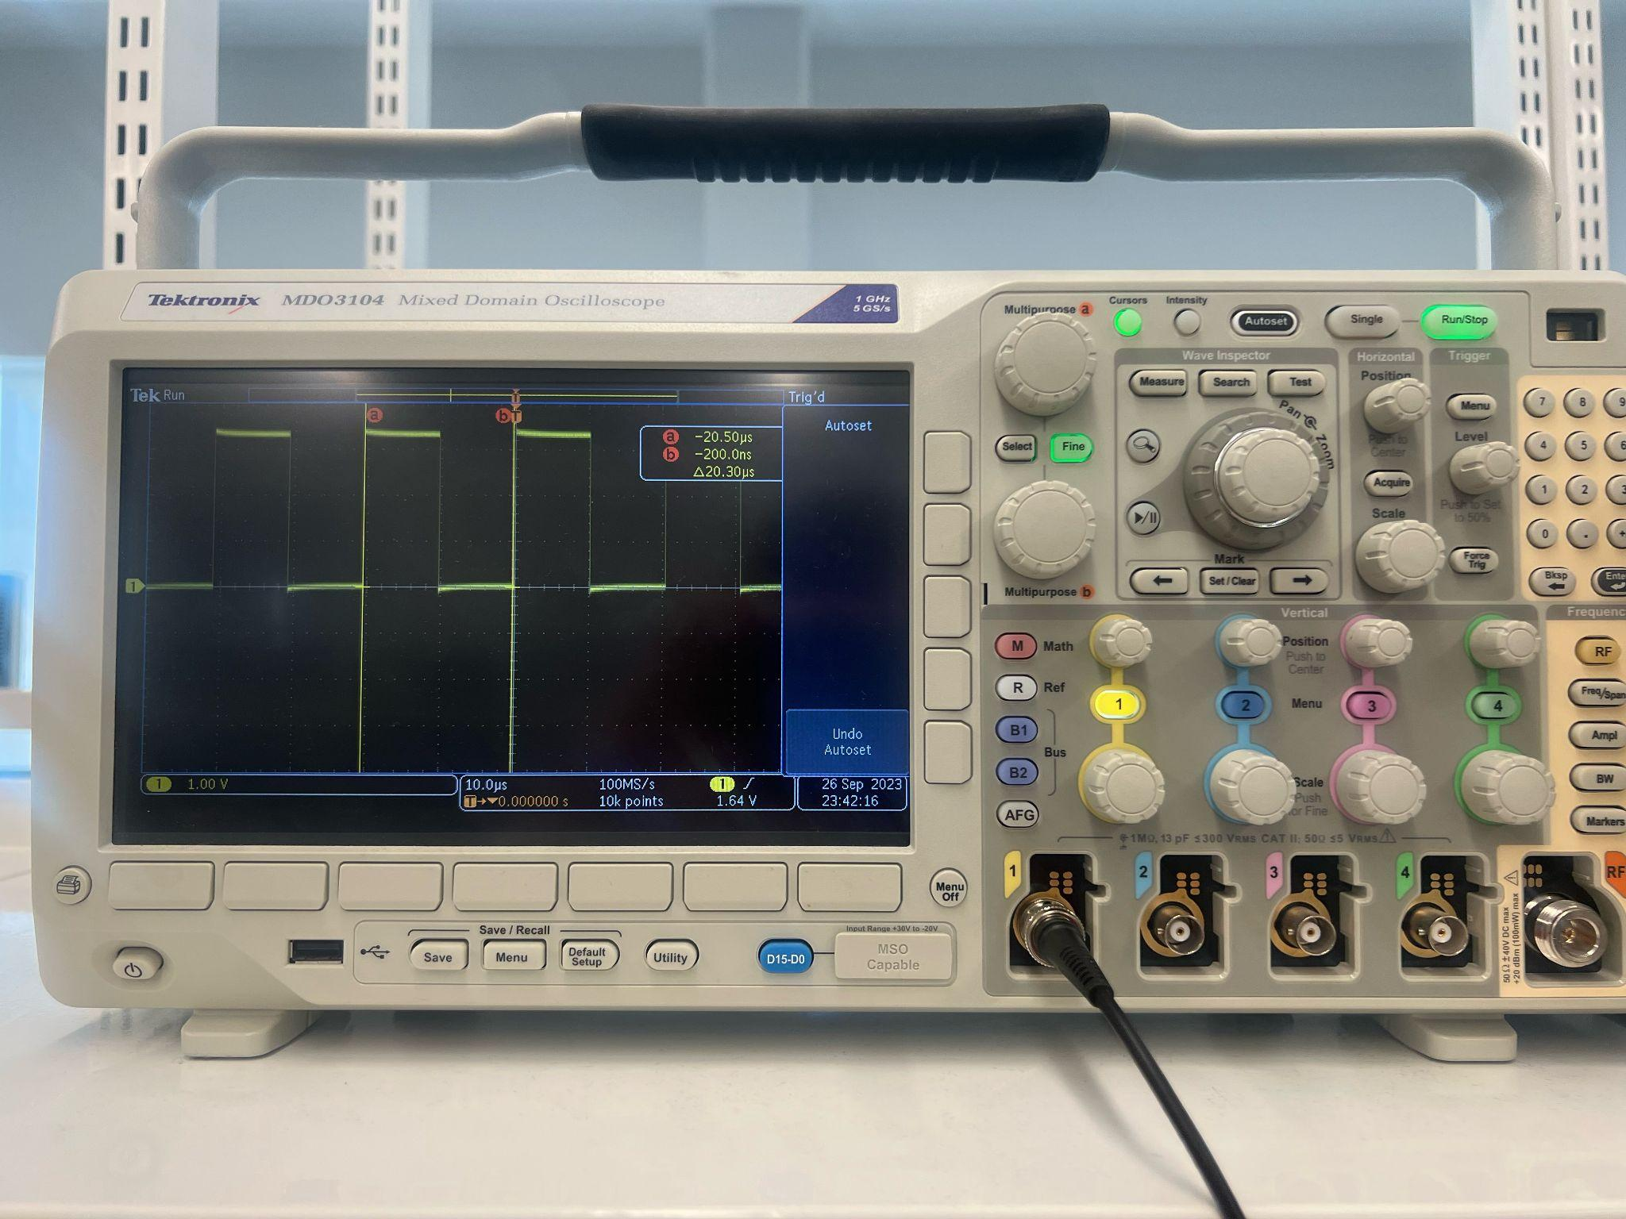

$20.30 μs=49261 Hz≈\frac{50*10^{6}}{2^{10}} Hz$

Part 2:

Function Code:

module freqDivider2(clk, reset, out);

input wire clk, reset;

output wire out;

reg [31:0] count_r; // current value

wire [31:0] count_n; // next value

always@(posedge clk)

begin

if(reset)

count_r <= 0;

else

count_r <= count_n;

end

assign count_n = count_r + 1;

assign out = count_r[18];

endmodule

Test Code:

//=======================================================

// This code is generated by Terasic System Builder

//=======================================================

module freqDividerTest2(

//////////// CLOCK //////////

input CLOCK_50,

input CLOCK2_50,

input CLOCK3_50,

//////////// LED //////////

output [8:0] LEDG,

output [17:0] LEDR,

//////////// KEY //////////

input [3:0] KEY,

//////////// GPIO, GPIO connect to GPIO Default //////////

inout [35:0] GPIO

);

//=======================================================

// REG/WIRE declarations

//=======================================================

wire reset, clk, my_signal;

assign reset = 1'b0;

assign clk = CLOCK_50;

assign GPIO[0] = my_signal;

//=======================================================

// Structural coding

//=======================================================

freqDivider2 U1(.clk(clk), .reset(reset), .out(my_signal));

endmodule

Output:

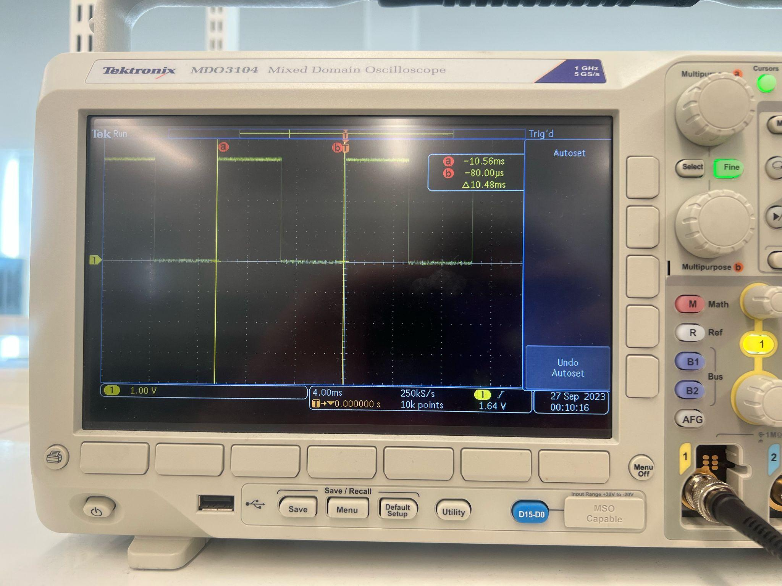

$10.48 μs=95.420 Hz≈100 Hz$